

Session 1

Assignment 1 Question *Session 1: Assignment 1*

**Table of Contents**

1. ​ Introduction​

2. ​ Problem Statement​

3. ​ Output​

**1.** ​ **Introduction**​

This assignment will help you to consolidate the concepts learnt in the session.

# 2. ​ Problem Statement​

**Task 1:**

1.

Install Jupyter notebook and run the first program and share the screenshot of the output.

LINK

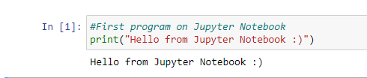

2.

Write a program which will find all such numbers which are divisible by 7 but are not a multiple of 5, between 2000 and 3200 (both included). The numbers obtained should be printed in a comma-separated sequence on a single line.

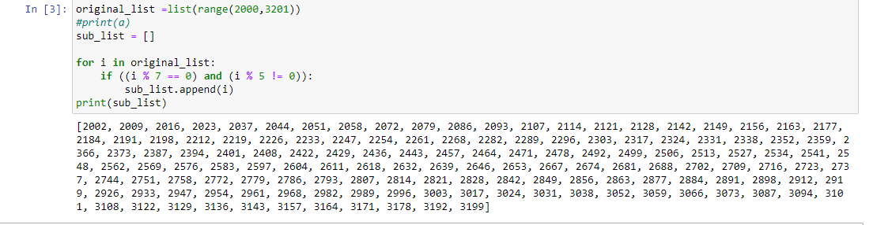

3.

Write a Python program to accept the user's first and last name and then getting them printed in the the reverse order with a space between first name and last name.

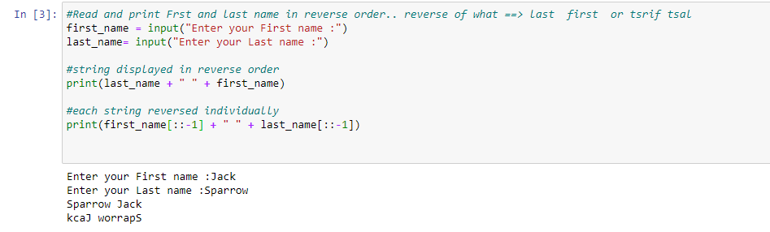

4.

Write a Python program to find the volume of a sphere with diameter 12 cm.

Formula: V=4/3 * π * r 3

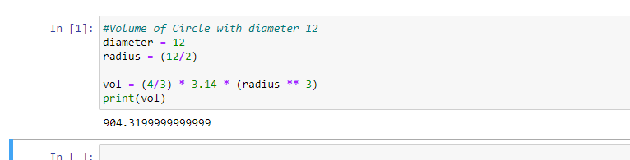

**Task 2:**

1.

Write a program which accepts a sequence of comma-separated numbers from console and generate a list.

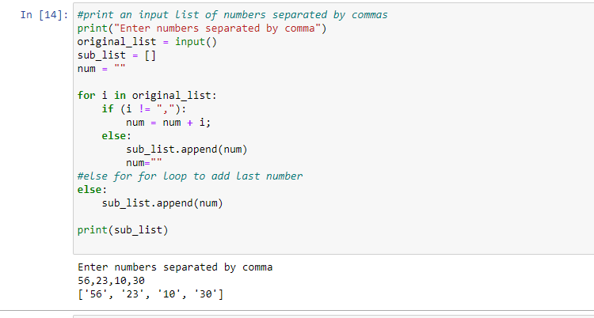

2.

Create the below pattern using nested for loop in Python.

*

* *
* * *
* * * *
* * * * *
* * * *
* * *
* *

*

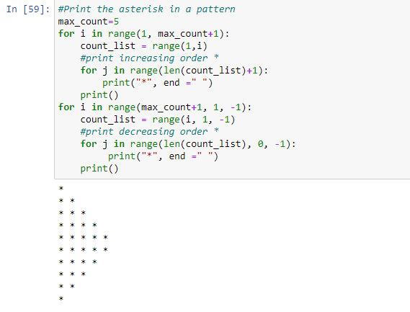

3.

Write a Python program to reverse a word after accepting the input from the user.

**Sample Output:**

Input word: AcadGild

Output: dilGdacA

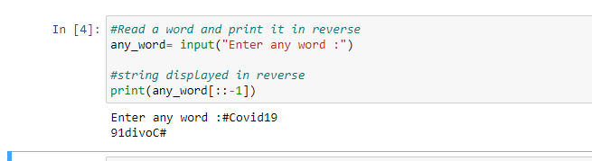

4.

Write a Python Program to print the given string in the format specified in the ​**sample output.**

WE, THE PEOPLE OF INDIA, having solemnly resolved to constitute India into a

SOVEREIGN, SOCIALIST, SECULAR, DEMOCRATIC REPUBLIC and to secure to all its citizens

**Sample Output:**

WE, THE PEOPLE OF INDIA,

having solemnly resolved to constitute India into a SOVEREIGN, !

SOCIALIST, SECULAR, DEMOCRATIC REPUBLIC

and to secure to all its citizens

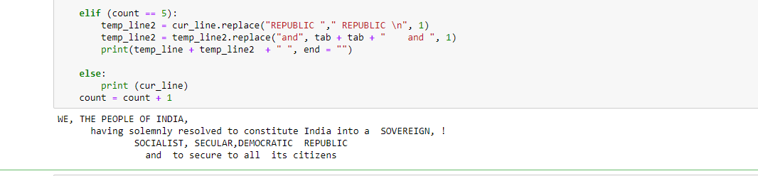

**NOTE:** ​ **The**​ ​ **solution**​ ​ **shared**​ ​ **through**​ ​ ​**Github** ​ **should**​ ​​**contain**​​**the**​​**source code**​​**used**​​ **and** ​ **the**​ ​ **screenshot**​ ​ **of**​ ​ **the**​ ​ **output.**​

# 3.​ Source code for the problems

## TASK 1

1. #First program on Jupyter Notebook

print("Hello from Jupyter Notebook :)")

1. #Program to print numbers between a range divisible by 7, not by 5

original_list =list(range(2000,3201))

#print(a)

sub_list = []

for i in original_list:

if ((i % 7 == 0) and (i % 5 != 0)):

sub_list.append(i)

print(sub_list)

1. #Read and print Frst and last name in reverse order.. reverse of what ==> last first or tsrif tsal

first_name = input("Enter your First name :")

last_name= input("Enter your Last name :")

#string displayed in reverse order

print(last_name + " " + first_name)

#each string reversed individually

print(first_name[::-1] + " " + last_name[::-1])

1. #Volume of Circle with diameter 12

diameter = 12

radius = (12/2)

vol = (4/3) * 3.14 * (radius ** 3)

print(vol)

## TASK 2

1. #print an input list of numbers separated by commas

print("Enter numbers separated by comma")

original_list = input()

sub_list = []

num = ""

for i in original_list:

if (i != ","):

num = num + i;

else:

sub_list.append(num)

num=""

#else for for loop to add last number

else:

sub_list.append(num)

print(sub_list)

# ​

1. #Print the asterisk in a pattern

max_count=5

for i in range(1, max_count+1):

count_list = range(1,i)

#print increasing order *

for j in range(len(count_list)+1):

print("*", end =" ")

print()

for i in range(max_count+1, 1, -1):

count_list = range(i, 1, -1)

#print decreasing order *

for j in range(len(count_list), 0, -1):

print("*", end =" ")

print()

1. #Read a word and print it in reverse

any_word= input("Enter any word :")

#string displayed in reverse

print(any_word[::-1])

1. #justification of given text

import textwrap

value = """WE, THE PEOPLE OF INDIA, having solemnly resolved to constitute India into a

SOVEREIGN, SOCIALIST, SECULAR, DEMOCRATIC REPUBLIC and to secure to all

its citizens"""

# Wrap this text.

wrapper = textwrap.TextWrapper(width=30)

out_lines = wrapper.wrap(text=value)

#print(out_lines)

count = 1

temp_line = ""

tab=" "

# Print each line in a different format

for cur_line in out_lines:

if (count == 1):

print(cur_line)

elif (count==2):

temp_line = temp_line + tab + cur_line + " "

elif (count == 3):

print(temp_line + cur_line + " ",end="")

elif (count == 4):

temp_line = cur_line.replace("SOVEREIGN,"," SOVEREIGN, ! \n", 1)

temp_line = temp_line.replace("SOCIALIST", tab + tab + " SOCIALIST", 1)

elif (count == 5):

temp_line2 = cur_line.replace("REPUBLIC "," REPUBLIC \n", 1)

temp_line2 = temp_line2.replace("and", tab + tab + " and ", 1)

print(temp_line + temp_line2 + " ", end = "")

else:

print (cur_line)

count = count + 1